1. **The following is 50-Day Moving Average for 1-Day Chart**.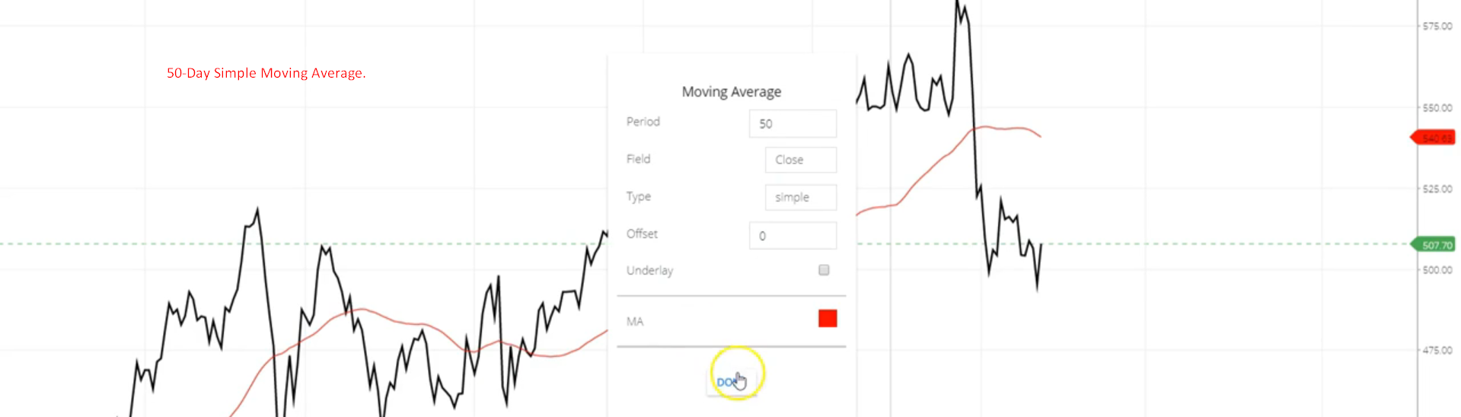
2. A graph with red line and black lines

   Description automatically generated